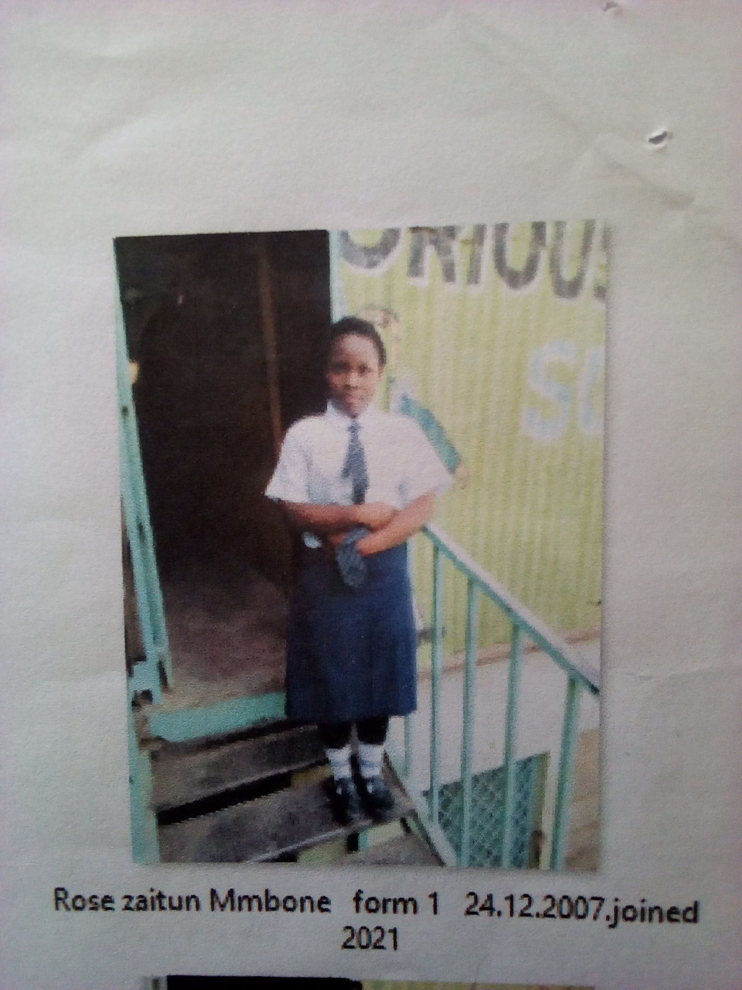

ROSE ZAITUN MMBONE FORM 1 BORN 2007 JOINED 2021
Rose 14 years was enrolled in our school when she was 14 years old. Rose is a promising girl staying with her auntie who has left all house chores to her. She started staying with her auntie after the untimely death of her parents. After we had examined her, Rose had suffered from trauma and depression at an early age. She was allowed in school; glorious is her hope for a bright future. Rose has a promising future she really needed help which she got at glorious.
Thanks to the Director Mr. Boniface Mangeti who allowed Rose in school. I am now learning in glorious at least I have a place I call home praying that one day God will help our school have good classes, toilets and enough facilities for learning. Thank you Michell and Brad for your support have really helped many in Mukuru

